Renton Fish and Game Club minutes for August 8th, 2019

Call to Order: Sam Hewlett called the meeting to order at 7:00 PM.

The following officers were present:

Directors: Sam Hewlett (President), Sean Wade (Vice President), Georgia Coulter, Ted Pit, Ken Wong, Diana Pinto, John Palmer & Scott Johnson.

Game Warden: Kevin Michellich

Absent: Robb Wolfe (excused)

Tribute to Roland Marsh member #477, and Life Member

Roland was a longtime volunteer at the club for many years before joining the Monday crew 14+ years ago. He also kept up on small projects at the widow’s homes near by his home, along with volunteering work for his church. Rolly was a gentleman and friend to all. He will be missed.

This picture taken the last time he shot at the range late in June. Rolly pasted on Friday 26th or Saturday morning. He was 84 years old.

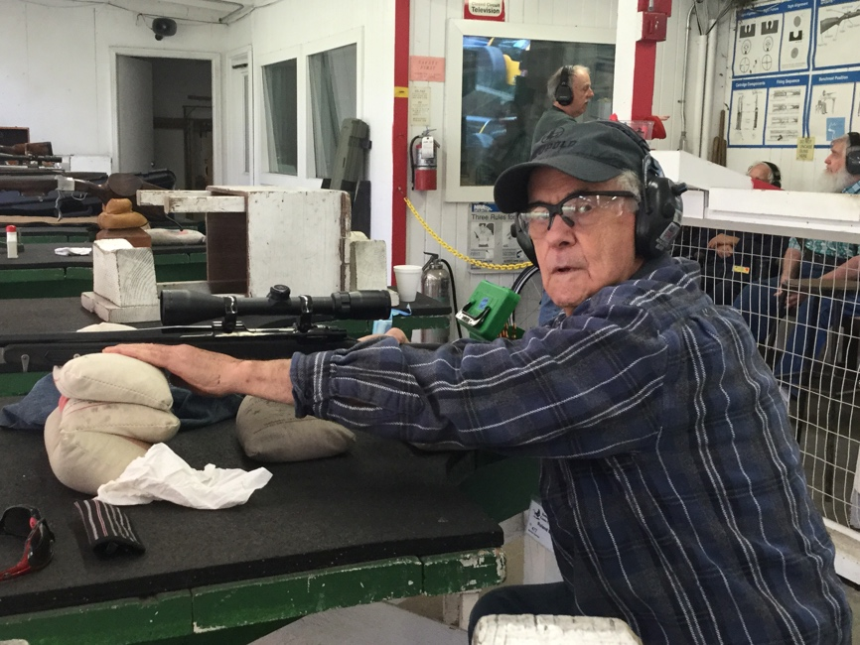

Announcements:

MSP (Motion Second and Passed) by John, seconded by Ted to approve the minutes, as corrected for July

Standing Committee Reports:

Archery Ted Pitt:
Archery looks good. Need to order bags

Trap & Skeet Ted Pitt:
Bunker is going well. At our state shoot we had 27 shooters, we brought in $1500.00
5 stand has been going, but slow at times. Working with White Flyer on a target issue in the bunker. Breakage has been high, also been that way at other clubs.

Cowboy, Derek Mirkle
Well, another great event is in the books.

A huge thank you to all those that helped to put this event on.
Lawbreaker, Carlsbad Kid (who didn't even shoot the match), Cedar County Sheriff, Half Fast Smitty, Just Dan D., Hank Hills, Heather Hills, Marcus Truegood, Dastardly Dean, T-Bone Shorty, Zwarte Piet and many more that I am surely forgetting. Without you guys and gals, these events would not happen.

We had 60 shooters this year. Five who have never shot this event.
The numbers may be down, as there were a lot of other things going on, but that didn’t stop those that showed up from having fun.

Our highest honor of Spirit of the Game was awarded to T-Bone Shorty.
An overwhelming thank you for all the help you provided for the entire week and more.

Congratulations to your new and repeat SASS Washington State Champions; Pinto Annie and Shalako Tucker.

Nine shooters managed to shoot the event clean.
Way to go Grip N’ Rip, Hey Granpa, Jed I Knight, Pinto Annie, Shalako Tucker, Shot-Z-Lady, Tacoma Slick, Wichita Wayne and Wiley Bob.

Lawbreaker was the man up front again. Runnin the mic, Chief stage organizer, Warmup side match coordinator, and so much more, even mental counselor to myself to make it through the match in one piece. People like you make it worth the time we put into these events.

We tried some new things this year and they were all received very well.

The Fast Gun Challenge was something we tried, and brought out 20 shooters and a lot of fun (knock down heaven).

Thank you to Cedar County Sheriff for putting the shooters books together, setting up both the Wild Bunch and Plainsman matches and many more behind the scenes.

Long Range Pistol caliber competitions were moved to Saturday in the down time after the match and before dinner. We had 20 shooters compete in each Match Pistol and Match Rifle challenge. Thank you again Marcus Trugood and Zwarte Piet for running these events. Definitely the most we've had in those events.

Dastardly Dean was our chief score keeper, thank you.

Greg Fortin once again helped out by running the Cowboy Trap on Friday afternoon. Thank you very much.

Thank you to Heather Hills and the Somewhere in Time – Unlimited for your work on the costume contest.

Awards and name tags were again by Pinto Annie and Shalako Tucker of ST Machine/Desperado Bullets.

Civilian Marksmanship Program (CMP), Don Miller:
The July CMP rifle match was held on the 27th with 2 shooters and $14.00 to the club. The next match will be in January.

Grounds, (open): Positon is open LaMarr reported
The Monday Crew kept up with general clean up, and target backers. More grass has been mowed on the pistol range and the rifle range out and around the 100-yard target placements. Installed the air conditioner in the rifle office and changed some light bulbs that we’re out. Replaced bulbs and lights on the down range on the pistol range. Moved logs by the dumpster. Dale and Roy de-energized electric panel in bay 1. Thanks goes out to the crew who along with Sam for cleaning up the down trees in bay one.
On the 29th we had our annual bar-bee-cue. A good time was had by all and thanks goes out the volunteers who continue to work and help keep the range looking good.

Hunter Education, Gary Emerson:
2 classes this month. One On line skills and one traditional.
Traditional registration reached maximum last week.
On line is 20% full as of this AM.

Conservation, Gary Emerson:
Watering of plants has begun. Vast majority are doing great so far.
Only a few have been eaten or died.

I noticed last Tuesday while watering that we have fence damage on southern property line directly south of the club house. Also, that someone has cut down dozens of shrubs and small trees on our side of the fence. Most of the plants cut down are native plants that have been planted over the past 15 years providing visual barrier in addition to wildlife habitat.
Does anyone know if did the cutting ourselves or provided permission for someone to cut the plants?

IDPA, Scott Johnson:
July 20th was the most recent IDPA Monthly Match.

There were 6 Stages, with 57 Shooters participating. There was a Classifier Match run after the regular match.

$955 was turned into the Club.

The next regularly scheduled Match will be on August 17th.

Membership, Sean
Membership as of 08-08-2019

Junior | 29
Annual | 329
Senior | 98
Family | 65
Military | 8
Life | 21
Total | 550
We have some life members who have moved out of the area and we need to find their current contact information.

Rifle and Pistol, Sam Hewlett:
Activity at the range was good this month. We had a total of 1008 people on the range. Of the 1008 members made up the vast majority. We had only 171 nonmember adults and 25 juniors that were paying which brought in $3,663.27. Two new spotting scopes were installed on the range this month one of which is being replaced by Redfield due to a malfunction. The range is in good condition thanks to the Monday crew.

July Kid’s day, Greg reported:
Forgot my camera today, so words are all you get.

Today it was "in by 10 and out by noon.
We filled up right from the start with 8 members and 9 non-members.
But, at noon everybody seemed to disappear. Only 3 kids from noon on?
Maybe the heat, or maybe Ken & Karen's BBQ.

Two were foreign exchange students from Japan that had never even seen a real firearm.
Their exchange sponsor was with them all the time, and they really did well.
He told me that this would be a once in a lifetime experience for them.

A very smooth day. Even a couple of parents got to pop some balloons.

Scholastic Clay Target Program, Bob Louser:

Still on Summer break but as of the 1st of August we are open to sign ups for new year. Looking forward to another fun year. Hopefully have real news for next month.

Steel Matches, Cel Alvarez:
There was no match in July. We will resume on August 11, 2019 with 6 Stages.

Treasurer’s Report, Georgia Coulter:
Balances (as of 08-08-2019):
Savings | $232,225.49
Checking | $51,694.58
CD | $100,704.37
Total | $384,624.44

USPSA, Alan Feucht:
This was our monthly club match for July 2019.

Stages: 7
MD: Dave McClure
Registration/Stats: Alan Feucht, Keith Tsang

Total of 83 competitors. There were 2 DQ's and no negligent discharges reported

Financials:
Gross Revenue: $1,670.00
Expenses: $416.23
Total Net Revenue: $1,253.77

Stats:
Junior: 2
Senior: 8
S. Senior: 6
Lady: 2
Military: 5
Law: 1
International: 1
Renton Members: 16
SO's: 8

Black Rifle League, Sean Wade:
We had 15 shooters.
The club took in $135.
It was the end of our season where we gave out prizes and had a bbq.

The next season kicks off in September.

Action Shooting International (ASI), Sandy Wylie:
Rick Breneman was the match director

81 competitors shot the match under clear skies.
One DQ resulting from an AD into the berm.

$1142 was turned into the club.

Precision Rimfire, Ken Wong:
PPR cancelled for Westmatch

Old Business:

- Updating member handbook and range rules (Ken Wong).
No update
- Diana’s proposal for general membership action bay use. Action Bay Committee will follow up
This proposal would establish scheduled action bay use by members who otherwise would not have bay use.
The following proposal would not affect the current use of action bays by RSO II members during range hours or after hours.
Members in good standing would attend a one-time orientation class, exact structure to be determined by Action Bay Committee, consisting of class time and hands-on time in the action bay. Classes would be offered on a monthly/every other month basis, tbd.
Action bays would be open to these members only, during range hours only (hours may change dependent on time of year) and on scheduled days only.
Action bay use would be a fixed day or days of the week, minimum 2 days per month.
Only limited bays would be available for use, possibly bays 1-3.
RF&G would hire an additional range master to work in the action bays on the general membership days. Volunteer range officers may also be asked to help.
Targets can be provided by members or can be put out by range master in the am for members to use, either steel or paper. Members would not have access to the targets or TCU directly, only range master or volunteer/discipline chairs.
- Sam reported that he has hired two part time employees: Spence Hansen & Paul Pellegrino.
- Action Bay Committee (Derek, Sean, Scott & Robb) items to follow up on (STILL IN WORK):
  - Follow on Karen’s suggestion about adding cameras in the action bays.
  - Keeping the brass and steel picked up - Sean to follow up with Glenn on the status of Vince. Sam was also going to follow up with Glenn
  - Charging non-members for official practices: In the past, the board allowed Brian to not charge visitors for the Friday night cowboy practices. Derek would like to continue that. After discussion, we came up with the idea of not charging for their first visit, but charging $5 for each practice after that. We need to decide if that is the way we want to go and probably get the Boards’ approval.
Sam asked that this go to an e-board session
  - Due to the problems we are having with people not following the rules, it is time to conduct a RSO recertification.
The idea is to conduct recertification sessions every two calendar years. We will need to issue a new RSOIII sticker so that it would be easy to see who has been recertified.
Anyone not going through the session would be decertified.
Need to work out the process.

New Business:
- Safety items:
  - No items to report
- Unhealthy tree removal in the action bays. Sam and Scott reported that they have identified trees that should be removed and have received a bid.
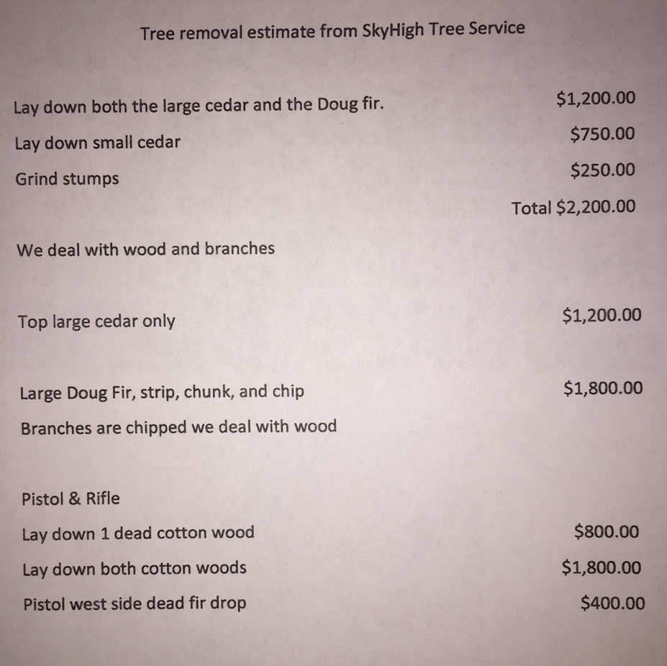

- The following was discussed and approved (MSP) to address member’s renewal issues.
  - Members and staff watch for people using the ranges with expired memberships. Those who are caught will be asked to renew their membership before they are allowed to use the range (or pay the daily fee).
  - Members with expired badges may be asked but are not required to return them.
  - Future badges will have the words: “Property of RFGC” printed on them.
  - Members who renew late, pay a late fee of $15 per month to a maximum of $60. The maximum for seniors would be $45
Example: a standard member renewing on September 1st will pay $190
  - Members who decline to pay their late fees will have their membership cancelled. They may reapply for membership on July 1 (next membership cycle).
  - This proposal will go into effect September 1st. Members who renew before September 1, 2019 and had not paid the previous year’s dues will be asked to pay the current year and maximum late fee of $60 or $45 (depending on their type of membership)
  - Active Duty Military who were deployed, and were not able to renew do not have to pay a late fee

 | Junior | Standard | Active Duty Military | Family | Senior
Annual | 1 | 160 | 125 | 185 | 80
Active member | 1 | 100 | 85 | 125 | 50
Late fee | N/A | $15 per month to a maximum of $60 | $15 per month to a maximum of $60 | $15 per month to a maximum of $60 | $15 per month to a maximum of $45

- RSO II Recertification issues. Is on hold until the Action Bay Committee brings their recommendations to the Board

Meeting adjourned at 8:30 PM

Submitted by Robert Wolfe, Secretary

